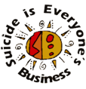

safeTALK WORKSHOP - REGISTRATION FORM
Date | Saturday 2 March 2024
Time | 9am – 12pm
Venue | Anglicare NT  5 Nemarluk Drive, Ludmilla

Name:

Employer:
(if community member please advise)

Phone: Mobile:

Email Address:

Please indicate Age Range: 16-24 ☐ 25-34 ☐ 35-44 ☐ 45-54 ☐ 55 + ☐
Please indicate your gender: Male ☐ Female ☐ Other ☐
Do you identify as Aboriginal and/or Torres Strait Islander? Yes ☐ No ☐

Do you identify as Culturally &/or Linguistically Diverse Yes ☐ No ☐

Agency Type:
Australian Government: ☐ Community member: ☐
NT Government: ☐ Indigenous Organisation: ☐
Local Government: ☐ Other:
Non-Govt Organisation: ☐

Sector:
Education: ☐ Accommodation: ☐
Mental Health: ☐ Counselling: ☐
Health: ☐ Youth: ☐
AOD: ☐ Police/Corrections: ☐
Domestic Violence: ☐ Defence: ☐
Aged Care: ☐ Employment: ☐
Disability: ☐ Legal: ☐
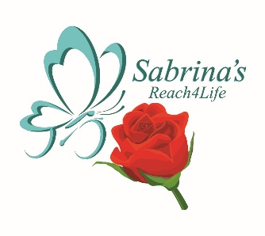
Student: ☐ Other:

Cost: FREE

Please email completed registration form to:
Bogusia Goring info@sabrinasreach4life.com.au

